Workshop: Regional Workshop on Phytocap Technology for Sustainable Waste Containment

Tentative Location: Waste Management Authority (Western Province) Srawasthi Mandiraya” 32, Sir Marcus Fernando Mawatha, Colombo -07
Tentative Dates: May 26-27, 2014
Background: Tipping of waste into uncontrolled dumpsites remains the most common practice of managing solid waste in developing countries such as India, Sri Lanka, Bangladesh, Pakistan and Nepal. Only a few waste disposal sites in developing countries are designed and operated as engineered sanitary landfills due to technical and financial constraints. Uncontrolled dumpsites are major source of surface and groundwater contamination as well as odor and greenhouse emissions. The Phytocap technology presents a natural soil-plant alternative to the conventional engineered landfill cover design. The Phytocaps constructed using local soils and native vegetation relying on natural processes of evaporation and transpiration, have been recently proven to be an effective alternative to more expensive conventional options to cover landfills. It requires less engineering input and has a lower cost than conventional impermeable covers as it only utilizes local recourses. It also offers the advantage of oxidizing methane to reduce landfill greenhouse emissions. Since the Phytocap is a containment technology, eventual controlled resource mining can be performed. Figure 1 shows a conceptual representation of the Phytocap Technology. The key ingredients for success are the selection of appropriate soil type to retain the moisture and the proper vegetation to uptake the retained moisture while oxidizing the methane. This type of covers has the potential to make a significant difference in the way that developing countries are capping their waste sites. Hence the Phytocaps can be used cost-effectively and sustainably in developing countries to cover old dumpsites and to cap new landfills, with an objective to minimize leachate generation by reducing water infiltration into waste and to mitigate greenhouse emission and odor by promoting methane oxidation in cover soil. Back in November, 2013 a team of experts from Australia and USA visited and very briefly presented the Phytocap technology to several key waste management agencies and scientific organization in Sri Lanka. Based on the interest of that visit, the same team of experts is proposing this regional workshop to present the details of the Phytocap technology to the rest of the waste management agencies in Sri Lanka as well as other technical and policy leaders in the Indian Subcontinent nations.
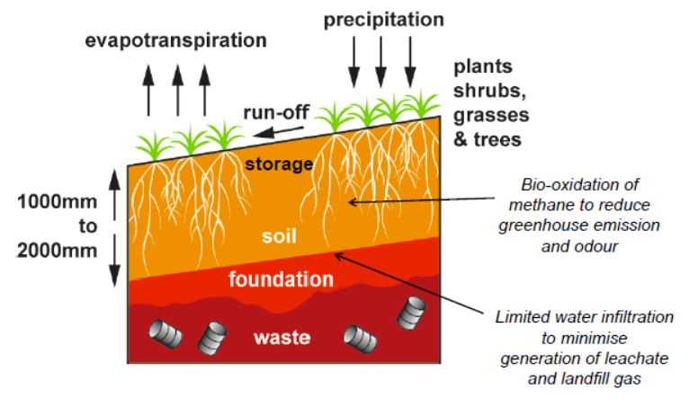
Figure 1 Conceptual Representation of the Phytocap Technology
Objectives: The main objective of the proposed workshop is to present the detailed scientific basis for local governments and regulators to adopt the Phytocaps as a practical and economical option to improve solid waste management for all nations in the Indian Subcontinent. Then to develop a core group of technical and policy leaders in the Indian Subcontinent who will bring this technology to respective nations and implement to improve the quality of life of citizens in the nations of the Indian Subcontinent. In addition participants will also explore incentives and barriers to successful implementation of the Phytocap technology.

Expected outcomes:
- Policy and technical brief on Sustainable Waste Containment.
- Position paper on the Phytocap technology for Sustainable Waste Containment in Indian Subcontinent and documentation of practical lessons of the Phytocap technology.
- Assemble a core group of technical and policy leaders in the Indian Subcontinent who would implement Phytocap technology in their country/region.
- Develop a plan of action to implement the Phytocap technology in the Indian Subcontinent nations including the development of a comprehensive proposal to construct prototype Phytocaps to confirm the regional feasibility of the technology.

Action Items: Dr. Yuen of University of Melbourne and Dr. Meegoda of New Jersey Institute of technology will draft the position paper before the workshop and circulate to the attendees for discussion and revisions. The attendees of the proposed workshop will first present the state of practice of waste management in their country/region. Then the details of the Phytocap technology will be presented. There is a brainstorming session to identify technical and societal barriers to the successful implementation of the Phytocap technology for Sustainable Waste Containment and propose solutions to overcome such barriers. The position paper will be revised based on the discussion during the workshop and will be submitted to UN. Finally there is a technical tour to showcase the recent advances in waste management in Sri Lanka.

